Inbound EFT Reconciliation
Bank Reconciliation Group
Date Last Updated: Jan 24, 2019
Contents
Overview 3
Glossary 3
Reports Required 3
Reconciliation 3
Recording Stats 5
Sample Tracking 5

Overview
Inbound EFT’s are reconciled every business day to ensure data integrity of the clearing processed by the banking system and by CAP Deposits. The transactions posted to the banking system are compared to the RBC transaction file reports to ensure all transactions are accounted for. Once the reconciliation is complete, a transfer between the internal offset account for inbound EFT’s and the RBC internal account is posted.

Glossary
Term | Definition
Inbound EFT | Incoming electronic funds transfers to our client or internal accounts form other FI’s

Reports Required
- T24 Report CAMB.EFTCAD.TRANS.REPORT & CAMB.EFTUSD.TRANSA.REPORT
  - These reports show all inbound EFT transactions posted by the banking system
- RBC Reports eftcdrpt.YYYYMMDD_HHMM.txt & eftusrpt. YYYYMMDD_HHMM.txt
  - )These reports show all transactions debited or credited to CWB by RBC
  - • 8:30am EFT files will be – eftcdrpt.15012019_0831.txt and eftusrpt.15012019_0831.txt
  - • 3:30pm EFT files will be – eftcdrpt.15012019_1531.txt and eftusrpt.15012019_1531.txt
  - • 8pm EFT files will be – eftcdrpt.15012019_2031.txt and eftusrpt.15012019_2031.txt
  - • 3am EFT files - eftcdrpt.txt and eftusrpt.txt
- CAD1099100011001 & USD1099100011001 Balances
  - The statement balance report must show the opening and closing balance of the internal account for the date(s) reconciled

Reconciliation
Step | Instruction
1 | Print the RBC File reports located: N:Drive\MISCommon\CAP\Previous Business Day eftcdrpt.YYYYMMDD_HHMM.txt & eftcdrpt.YYYYMMDD_HHMM.txt Run the HOBS MACRO to reformat the reports before printing. There will be for files per day.
2 | Open the Rec Spreadsheet located here: \\cwb.local\shared\Corp\CAP\Reconciliations\INBOUND EFT\Inbound_EFT_Rec.xlsx enter all 4 file details (File #, DB Count and Amount, CR Count and Amount).  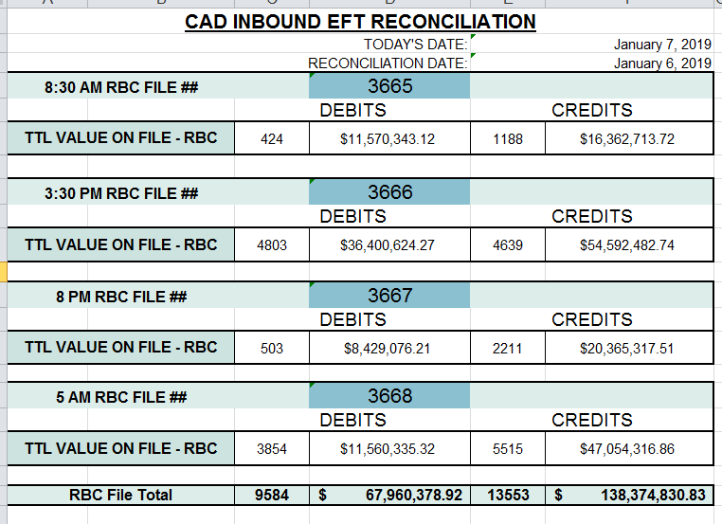
2 | Pull the T24 summary reporting: Log into T24 Clearing Reports & Enquiries EFT Incoming ClearingEFT SUMMARY REPORT  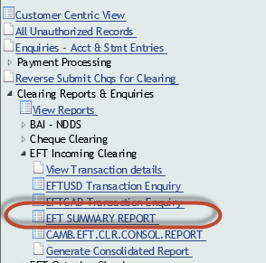
3 | Enter the File Creation Number in the Sequence # field (found on the RBC reports printed) and enter the currency of the file and the date in the @ID field (@ID contains CWBEFTUSD…YYYYMMDD…).  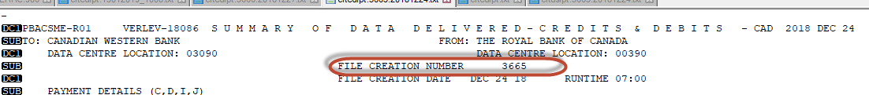  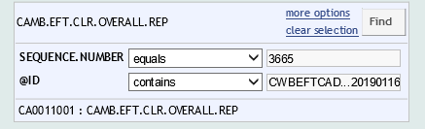
4 | Enter in the totals for the file into the rec.  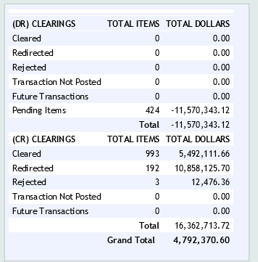  The difference between the files should be 0.00 if not, investigate and correct any outages  Confirm that the correct data was pulled (T24 issue, sometimes numbers do not match), the total amountof the Debit and Credit items (Listed at the bottom of the report) should match the RBC file. If it doesn’t, try again. If you have tried over 3 times, advise management. Also, if there are any Future Transactions, then the file is still running (common on month-end), wait until there are 0 Future Transactions to continue.  Take a screenshot of the totals, add to a word document and enter the totals into the spreadsheet. Repeat steps 3-5 for second file.
5 | The difference between the 4 files should be 0.00 if not, investigate and correct any outages.  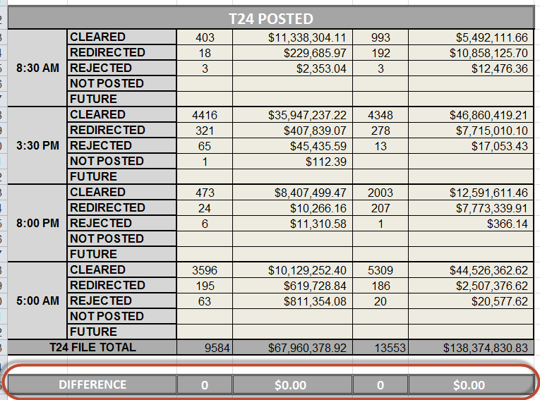
5 | Print the closing balance of the 10991 internal accounts for both CAD and USD for today’s date. This needs to be done before 8:30 AM, as the next file will be posted and throw the rec out.  Log into T24Enquiry- Acct & Stmt Entries  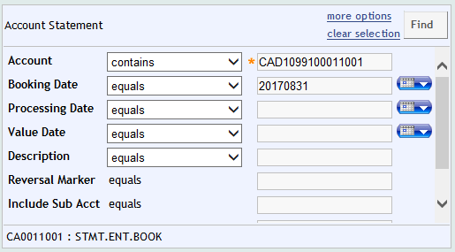
6 | Enter the closing Balance into the spreadsheet the difference should now be 0.00. If there is an outage, investigate and correct. Check to see if any EFT reversals were done, if not, compare the T24 posting file to the IA postings. See:  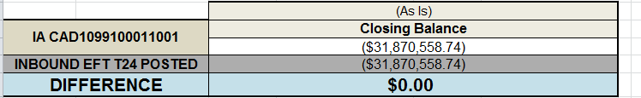
7 | Follow the same process to complete the USD Inbound EFT reconciliation.
8 | Once both CAD & USD Recs are complete, post the account transactions located on the “POSTING” worksheet, within the rec.
9 | After both the USD and CAD postings are done, check the CAD10991 & USD10991 closing balance as of today, they should be at 0.00. If they are not, check your postings to ensure they were done correctly.  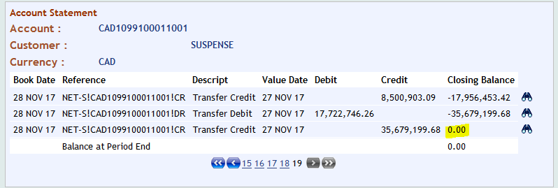
10 | Attach all paperwork, initial each page and hand into a checker for verification.

8:30AM File Rec
Step | Instruction
1 | Pull the RBC File reports located: N:Drive\MISCommon\CAP\Previous Business Day eftcdrpt.####.YYYYMMDD.txt & eftusrpt.####.YYYYMMDD. Where #### is the sequence number of the file and the date is the date when the file was processed. Run the HOBS MACRO to reformat the report before printing.
2 | Open the File Rec Spreadsheet located here: \\cwb.local\shared\Corp\CAP\Reconciliations\INBOUND EFT\File_Rec.xlsx enter in the file details (File #, DB Count and Amount, CR Count and Amount).  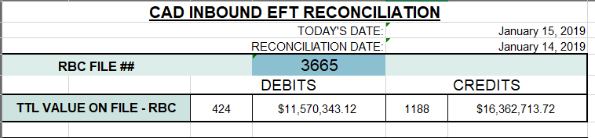
2 | Pull the T24 summary reporting: Log into T24 Clearing Reports & Enquiries EFT Incoming ClearingEFT SUMMARY REPORT
3 | Enter the File Creation Number in the Sequence # field (found on the RBC reports printed) and enter the currency of the file and the date in the @ID field (@ID contains CWBEFTUSD…YYYYMMDD…).
4 | Enter in the totals into the rec. All debits should be in Pending status, if they are not, alert management immediately.  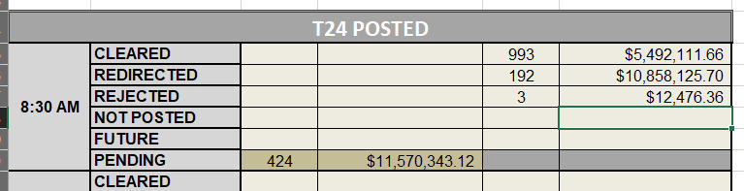  The difference between the files should be 0.00 if not, investigate and correct any outages  Confirm that the correct data was pulled (T24 issue, sometimes numbers do not match), the total amountof the Debit and Credit items (Listed at the bottom of the report) should match the RBC file. If it doesn’t, try again. If you have tried over 3 times, advise management. Also, if there are any Future Transactions, then the file is still running (common on month-end), wait until there are 0 Future Transactions to continue.
5 | Pull the closing balance of the 10991 internal accounts for both CAD and USD for today’s date.  Log into T24Enquiry- Acct & Stmt Entries
6 | Enter the closing Balance into the spreadsheet the difference should now be 0.00. If there is an outage, investigate and correct. Check to see if any EFT reversals were done, if not, compare the T24 posting file to the IA postings. See:
7 | Follow the same process to complete the USD Inbound EFT reconciliation.
8 | Save the daily rec in the drive : \\cwb.local\shared\Corp\CAP\Reconciliations\INBOUND EFT\File Recs\

3:30PM File Rec
Step | Instruction
1 | Pull the RBC File reports located: N:Drive\MISCommon\CAP\Previous Business Day eftcdrpt.####.YYYYMMDD.txt & eftusrpt.####.YYYYMMDD. Where #### is the sequence number of the file and the date is the date when the file was processed. Run the HOBS MACRO to reformat the report before printing.
2 | Open the saved Reject EFT Report for that day located here (this should have been saved at the 8:30 AM pull):  \\cwb.local\shared\Corp\CAP\Reconciliations\INBOUND EFT\File Recs\
2 | Pull the T24 summary reporting: Log into T24 Clearing Reports & Enquiries EFT Incoming ClearingEFT SUMMARY REPORT
3 | Enter the File Creation Number in the Sequence # field (found on the RBC reports printed) and enter the currency of the file and the date in the @ID field (@ID contains CWBEFTUSD…YYYYMMDD…).
4 | Enter in the totals into the rec. All debits should be in Pending status, if they are not, alert management immediately.  The difference between the files should be 0.00 if not, investigate and correct any outages  Confirm that the correct data was pulled (T24 issue, sometimes numbers do not match), the total amountof the Debit and Credit items (Listed at the bottom of the report) should match the RBC file. If it doesn’t, try again. If you have tried over 3 times, advise management. Also, if there are any Future Transactions, then the file is still running (common on month-end), wait until there are 0 Future Transactions to continue.
5 | Pull the closing balance of the 10991 internal accounts for both CAD and USD for today’s date.  Log into T24Enquiry- Acct & Stmt Entries
6 | Enter the closing Balance into the spreadsheet the difference should now be 0.00. If there is an outage, investigate and correct. Check to see if any EFT reversals were done, if not, compare the T24 posting file to the IA postings. See:
7 | Follow the same process to complete the USD Inbound EFT reconciliation.

Recording Stats
CAP Deposits records stats on all inbound EFT clearing to track volumes and trends.
- Once the reconciliation has been completed, open the tracking sheet located: G:\Clearing Issues\YEAR EFT CLEARINGS.
- Enter the total number of files, rejected and the total dollar value for both CAD and USD

Sample Tracking
